LIQUID CRYSTAL DISPLAY

LEARNING OBJECTIVES:-

* Explain the components of an LCD system
* Describe the process for making LCD glass
* Illustrate a typical glassy structure
* Define a liquid crystal
* Discuss the applications of liquid crystal display

INPUTS

**P2^0 (rs):** This is the control signal pin connected to the RS (Register Select) pin of the LCD. It selects between sending commands (rs=0) and sending data (rs=1) to the LCD

**P2^1 (rw):** This is the control signal pin connected to the RW (Read/Write) pin of the LCD. It selects between reading (rw=1) and writing (rw=0) data to/from the LCD. In this code, it's always set to write mode (rw=0), indicating that data is being written to the LCD.

**P2^2 (e):** This is the control signal pin connected to the Enable (E) pin of the LCD. It is used to latch the data present on the data bus of the LCD when transitioning from high to low.

OUTPUTS

**P1:** This port is used to send data and commands to the LCD. In the provided code, it's used for both writing commands (WriteCommandToLCD) and writing data (WriteDataToLCD) to the LCD.

LOGIC

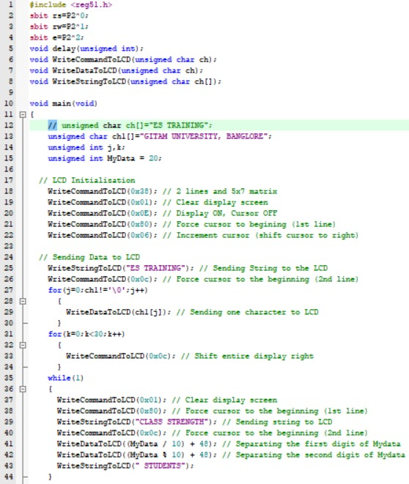

RESULT:-

the code interfaces with an LCD and displays the following information:

1. "ES TRAINING" on the first line of the LCD.
2. "GITAM UNIVERSITY, BANGLORE" on the second line of the LCD.
3. Continuously updates the LCD to display "CLASS STRENGTH XX STUDENTS" where "XX" represents the value of MyData.

The program runs indefinitely, continuously updating the LCD display with the current value of MyData and the message "CLASS STRENGTH" followed by the number of students.